KUBERNETES – 01
1. Setup Minikube in your local machine.
checked Docker version:
docker --version
Output:
Docker version 28.5.1
Docker is installed and working
(Minikube will use Docker as the driver)
🔹 Step 2: Create Minikube Directory
created a folder in C drive:
New-Item -Path "C:\" -Name "minikube" -ItemType Directory -Force
Directory created:
C:\minikube
🔹 Step 3: Download Minikube Binary
downloaded minikube.exe:
$ProgressPreference = 'SilentlyContinue'
Invoke-WebRequest -OutFile "c:\minikube\minikube.exe" `
-Uri "https://github.com/kubernetes/minikube/releases/latest/download/minikube-windows-amd64.exe" `
-UseBasicParsing
Now:
C:\minikube\minikube.exe
🔹 Step 4: Add Minikube to System PATH
updated environment variable:
$oldPath = [Environment]::GetEnvironmentVariable("Path", [EnvironmentVariableTarget]::Machine)

if ($oldPath.Split(";") -notcontains "C:\minikube") {
[Environment]::SetEnvironmentVariable("Path", "${oldPath};C:\minikube", [EnvironmentVariableTarget]::Machine)
}
This allows you to run minikube from anywhere.
🔹 Step 5: Verify Minikube Installation
In Git Bash / PowerShell:
minikube version
Output:
minikube version: v1.38.0
Minikube installed successfully
🔹 Step 6: Start Minikube Cluster
started Minikube using Docker driver:
minikube start
From your screenshot:
- Automatically selected Docker driver
- Using container runtime: containerd
- Pulled Kubernetes base image
- Created control-plane node
- Configured CNI
- Enabled addons:
  - storage-provisioner
  - default-storageclass
Cluster successfully started

🔹 Step 7: Verify Minikube Cluster
Check cluster IP:
minikube ip
Output: 192.168.49.2
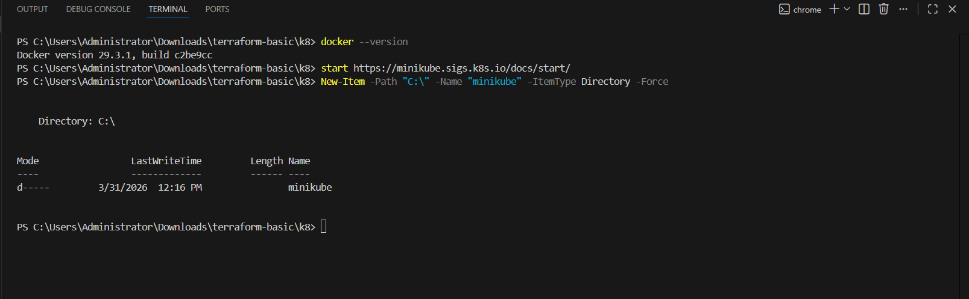
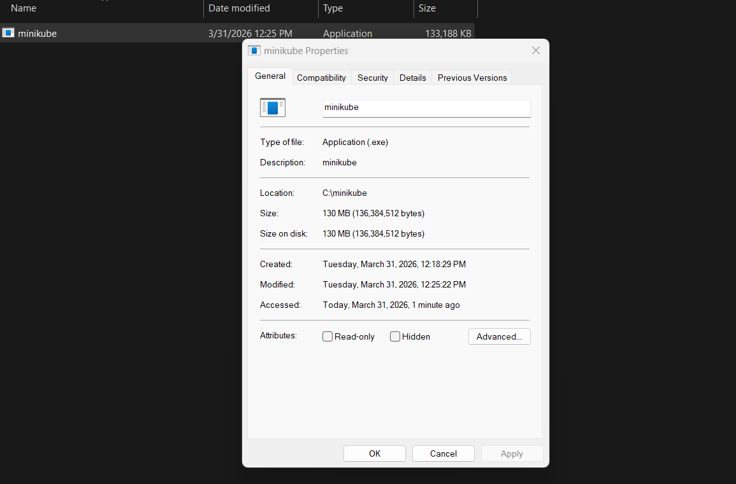
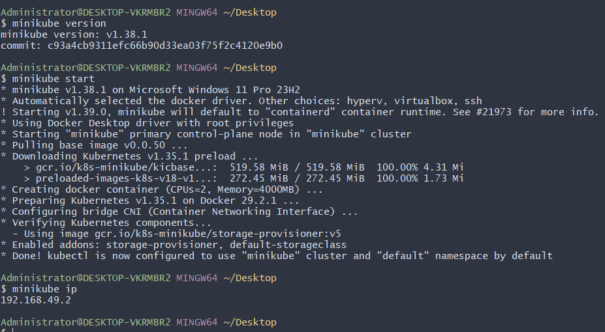
2. Setup k8s master and two worker nodes on ubuntu.
🔹 Step 1: Launch EC2 Instances (3 Ubuntu Servers)
You launched:
• k8s-master
• worker-01
• worker-02
Configuration:
• Ubuntu 24.04 LTS
• Same VPC
• Same Security Group
• Multiple AZs
• C7I LARGE
• 20GB storage
• On all nodes sudo swapoff -a

🔹 Step 2: Configure Hostnames (All Nodes)
On Master:
sudo hostnamectl set-hostname k8s-master
On Worker-01:
sudo hostnamectl set-hostname worker01
On Worker-02:
sudo hostnamectl set-hostname worker02

🔹 Step 3: Update /etc/hosts (All Nodes)
added private IP mappings for internal communication.
Example:
sudo vi/etc/hosts
Added:
172.31.72.39 k8s-master
172.31.74.23worker01
172.31.75.61 worker02

🔹 Step 4: Disable Swap (All Nodes)
sudo swapoff -a
free -h
To make permanent:
sudo sed -i '/ swap / s/^/#/' /etc/fstab

🔹 Step 5: Enable Required Kernel Modules (All Nodes)
Create Kubernetes config:
cat <<EOF | sudo tee /etc/modules-load.d/k8s.conf
overlay
br_netfilter
EOF
Load modules:
sudo modprobe overlay
sudo modprobe br_netfilter

🔹 Step 6: Set Sysctl Parameters (All Nodes)
cat <<EOF | sudo tee /etc/sysctl.d/k8s.conf
net.bridge.bridge-nf-call-iptables = 1
net.bridge.bridge-nf-call-ip6tables = 1
net.ipv4.ip_forward = 1
EOF
Apply without reboot:
sudo sysctl --system

🔹 Step 7: Install Kubernetes Components (All Nodes)
Add Kubernetes Repository:
sudo apt update
sudo apt install -y apt-transport-https ca-certificates curl gpg
sudo mkdir -p /etc/apt/keyrings

curl -fsSL https://pkgs.k8s.io/core:/stable:/v1.29/deb/Release.key | \
sudo gpg --dearmor -o /etc/apt/keyrings/kubernetes-apt-keyring.gpg

echo "deb [signed-by=/etc/apt/keyrings/kubernetes-apt-keyring.gpg] \
https://pkgs.k8s.io/core:/stable:/v1.29/deb/ /" | \
sudo tee /etc/apt/sources.list.d/kubernetes.list
Install Packages:
sudo apt update
sudo apt install -y kubelet kubeadm kubectl
sudo apt-mark hold kubelet kubeadm kubectl
Verify:
kubectl version --client
kubeadm version

🔹 Step 8: Install Container Runtime (All Nodes)
You installed containerd:
sudo apt install -y containerd
sudo mkdir -p /etc/containerd
sudo containerd config default | sudo tee /etc/containerd/config.toml
Enable systemd cgroup:
sudo sed -i 's/SystemdCgroup = false/SystemdCgroup = true/' /etc/containerd/config.toml
Restart & Enable:
sudo systemctl restart containerd
sudo systemctl enable containerd
sudo systemctl status containerd

🔹 Step 9: Initialize Kubernetes Cluster (Master Only)
sudo kubeadm init --pod-network-cidr=192.168.0.0/16
After successful initialization:
mkdir -p $HOME/.kube
sudo cp -i /etc/kubernetes/admin.conf $HOME/.kube/config
sudo chown $(id -u):$(id -g) $HOME/.kube/config
Check:
kubectl get nodes

🔹 Step 10: Install CNI (Calico) – Master Only
kubectl create -f https://raw.githubusercontent.com/projectcalico/calico/v3.26.1/manifests/tigera-operator.yaml
curl -O https://raw.githubusercontent.com/projectcalico/calico/v3.26.1/manifests/custom-resources.yaml
kubectl create -f custom-resources.yaml
Verify:
kubectl get pods -A
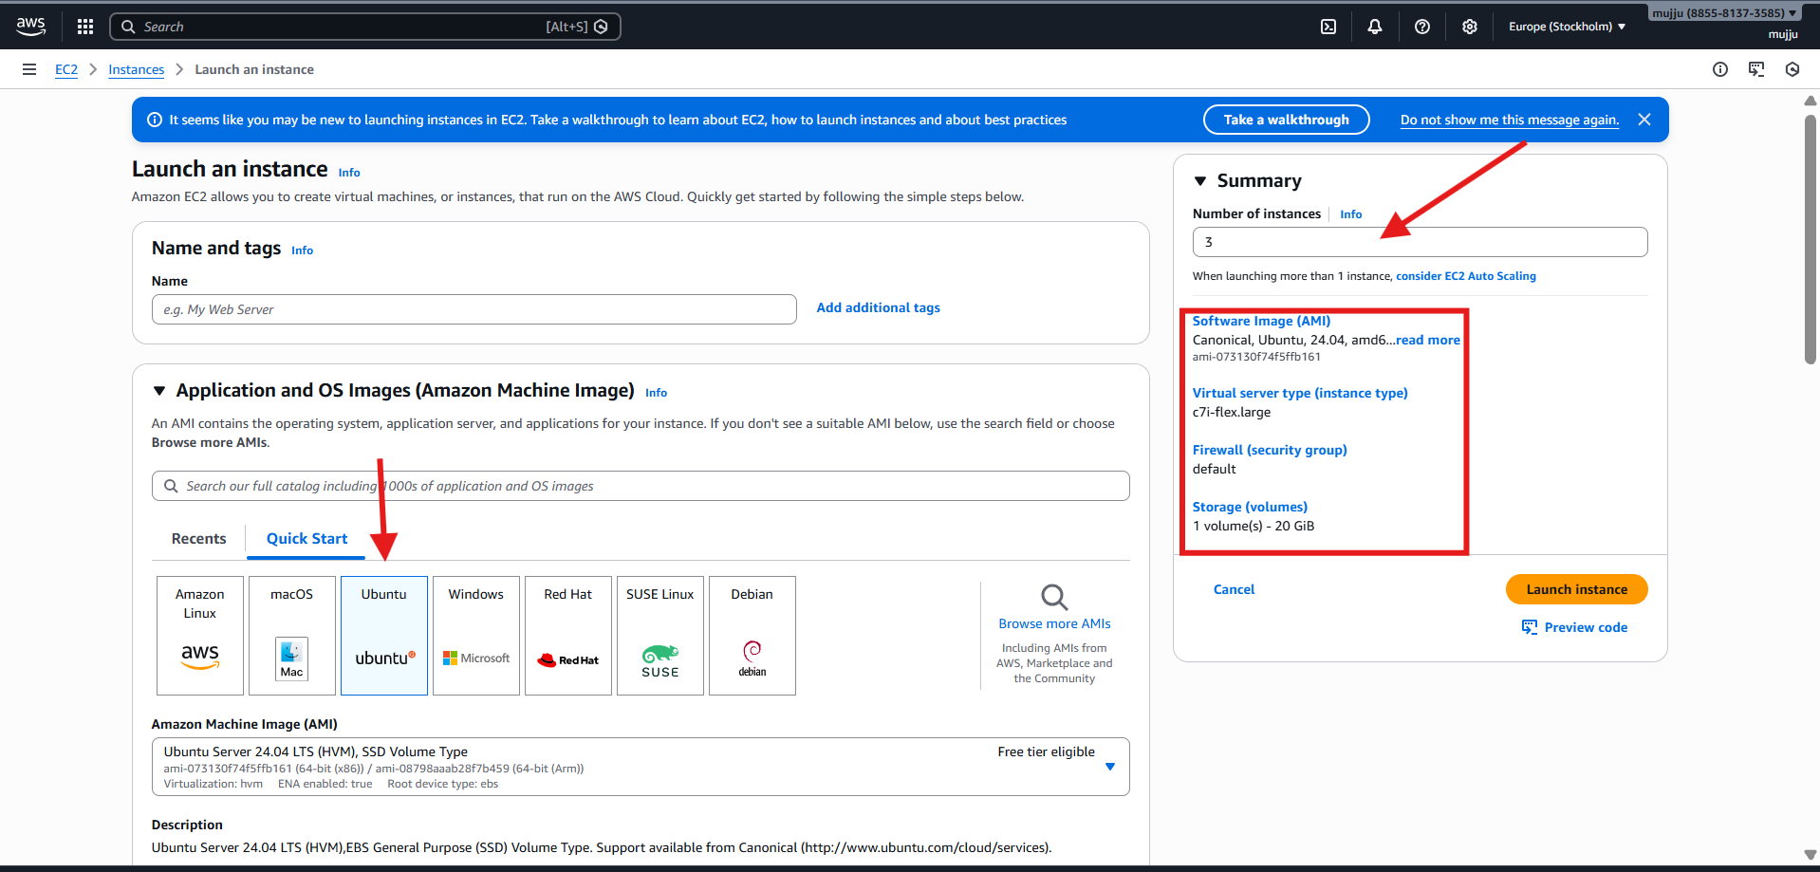
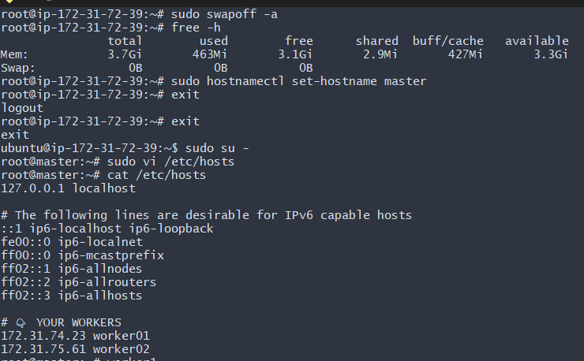
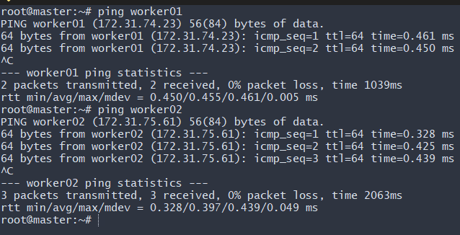
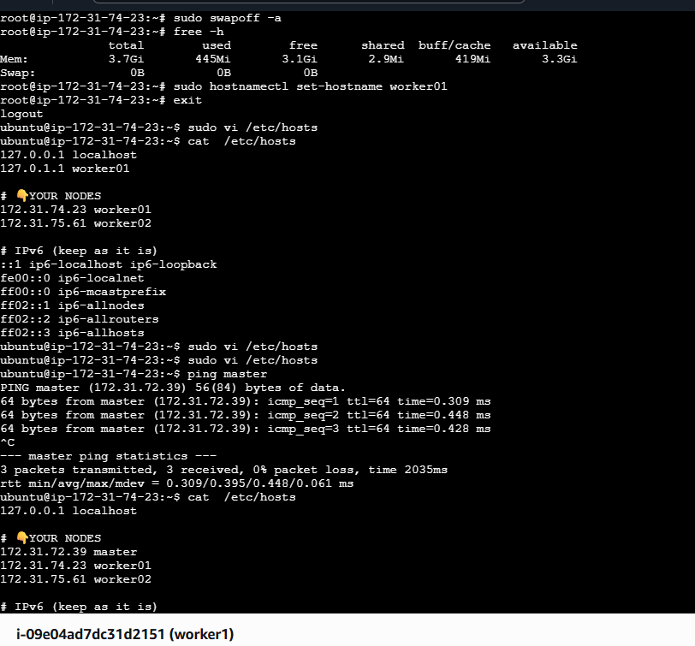
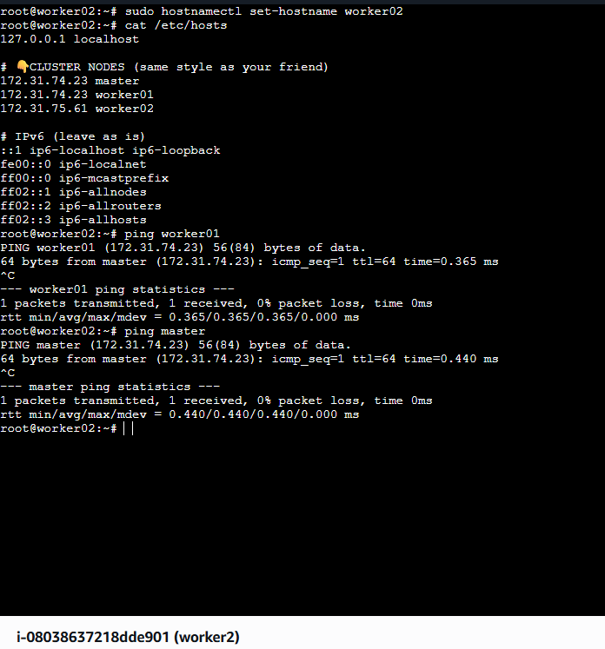
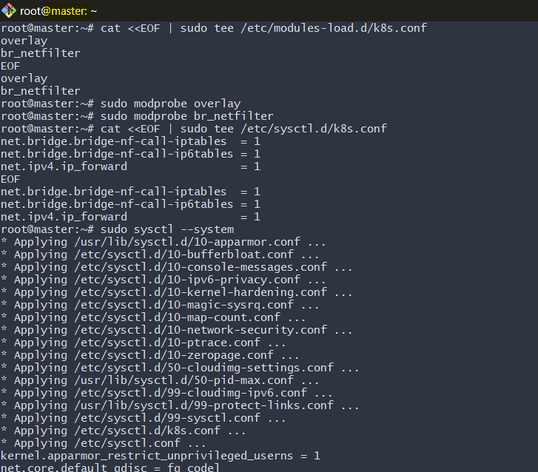
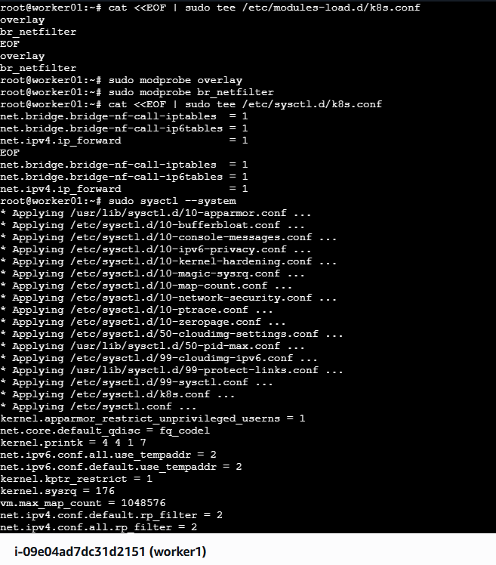
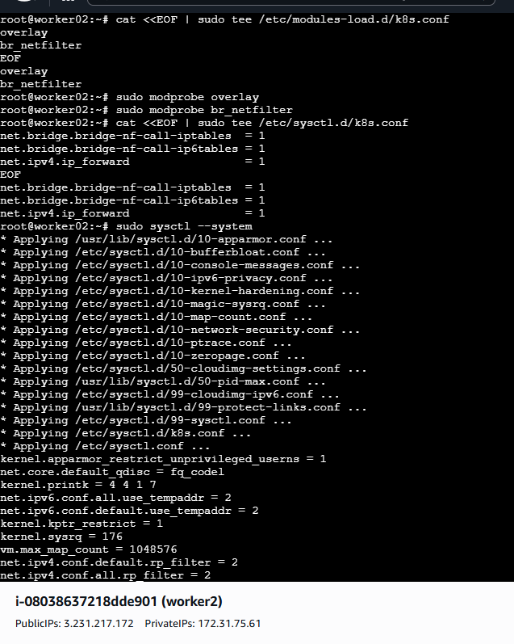
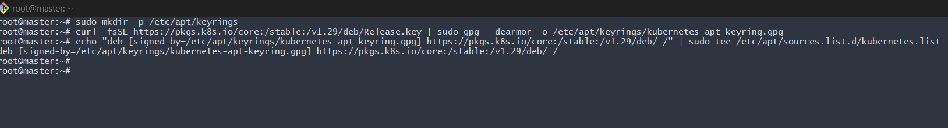
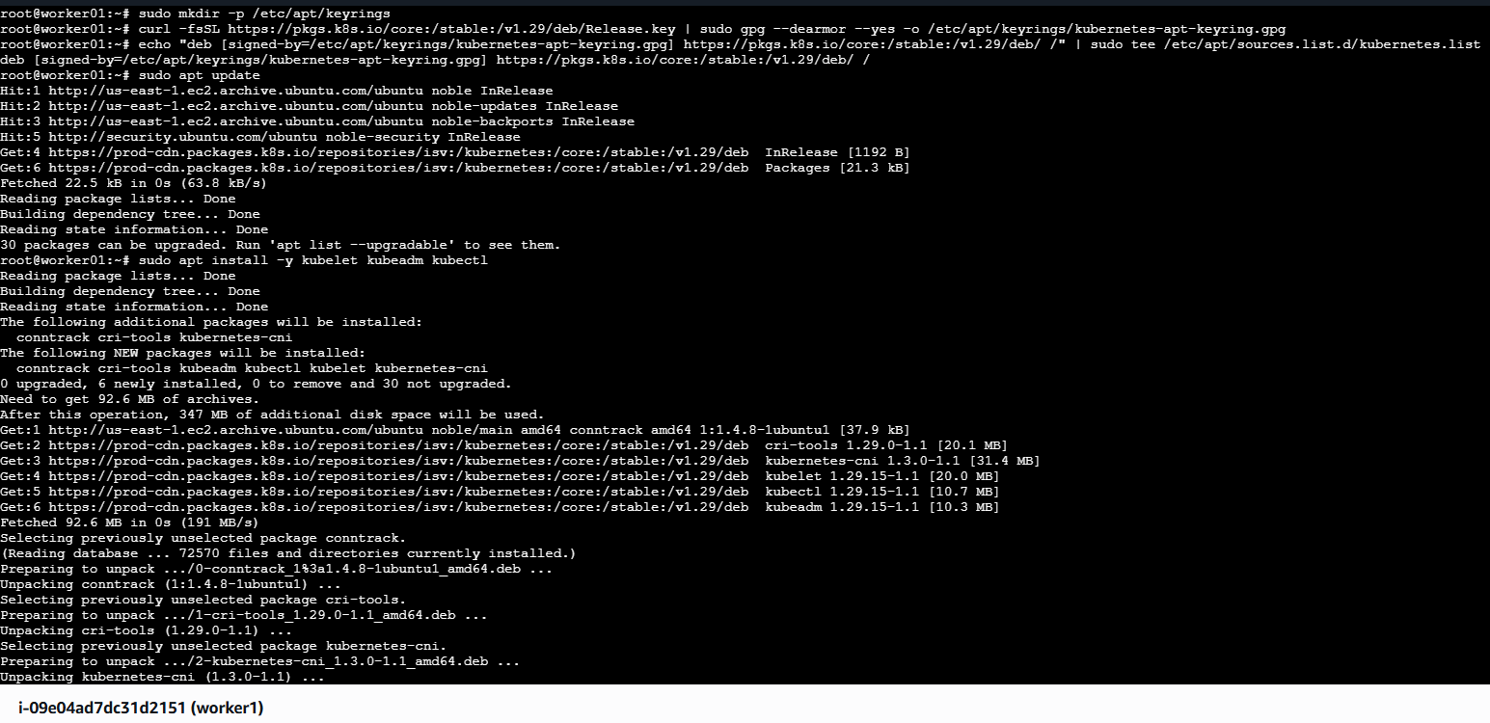
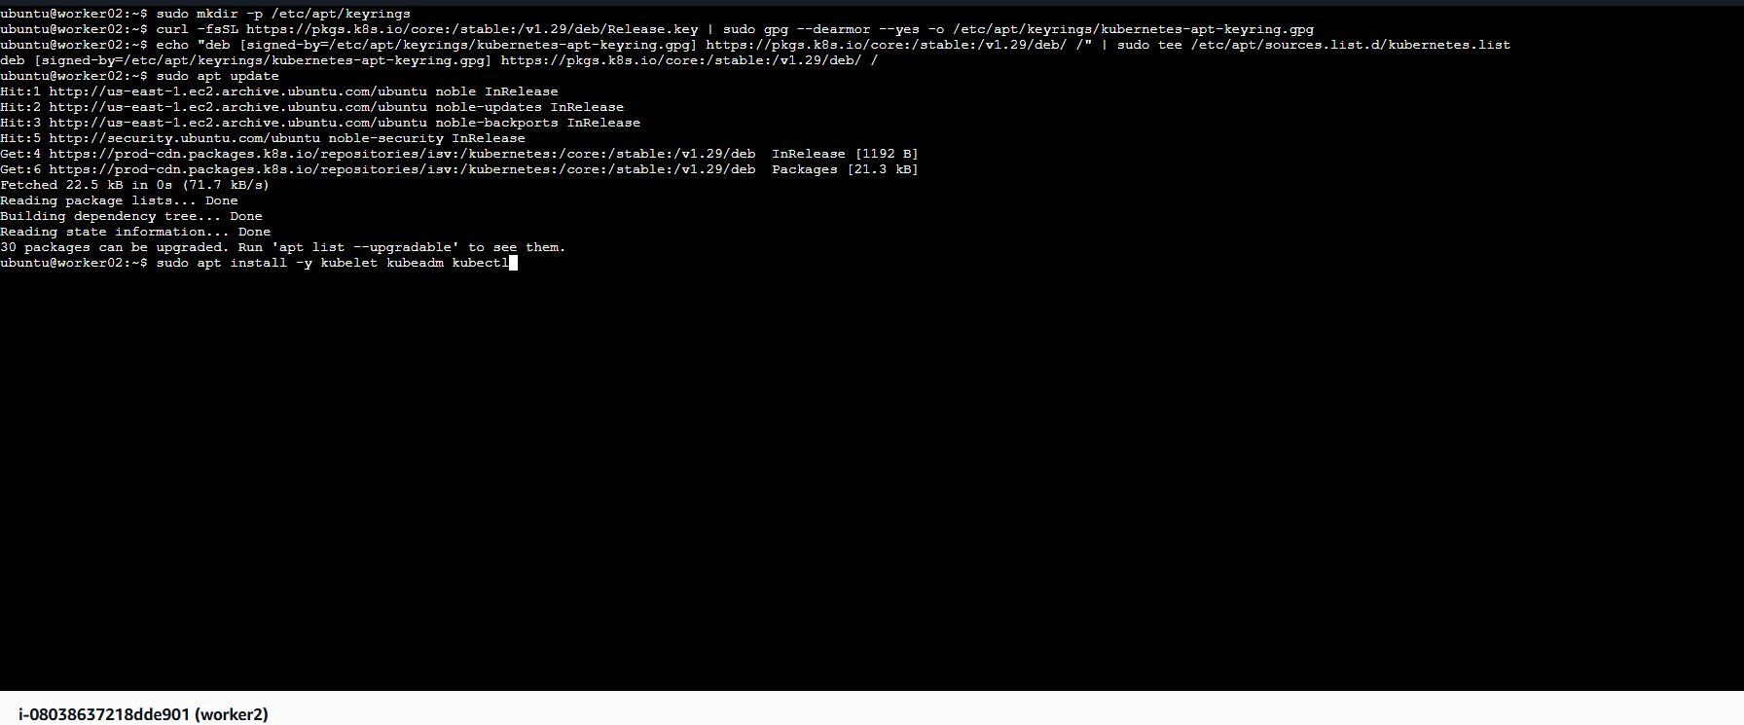
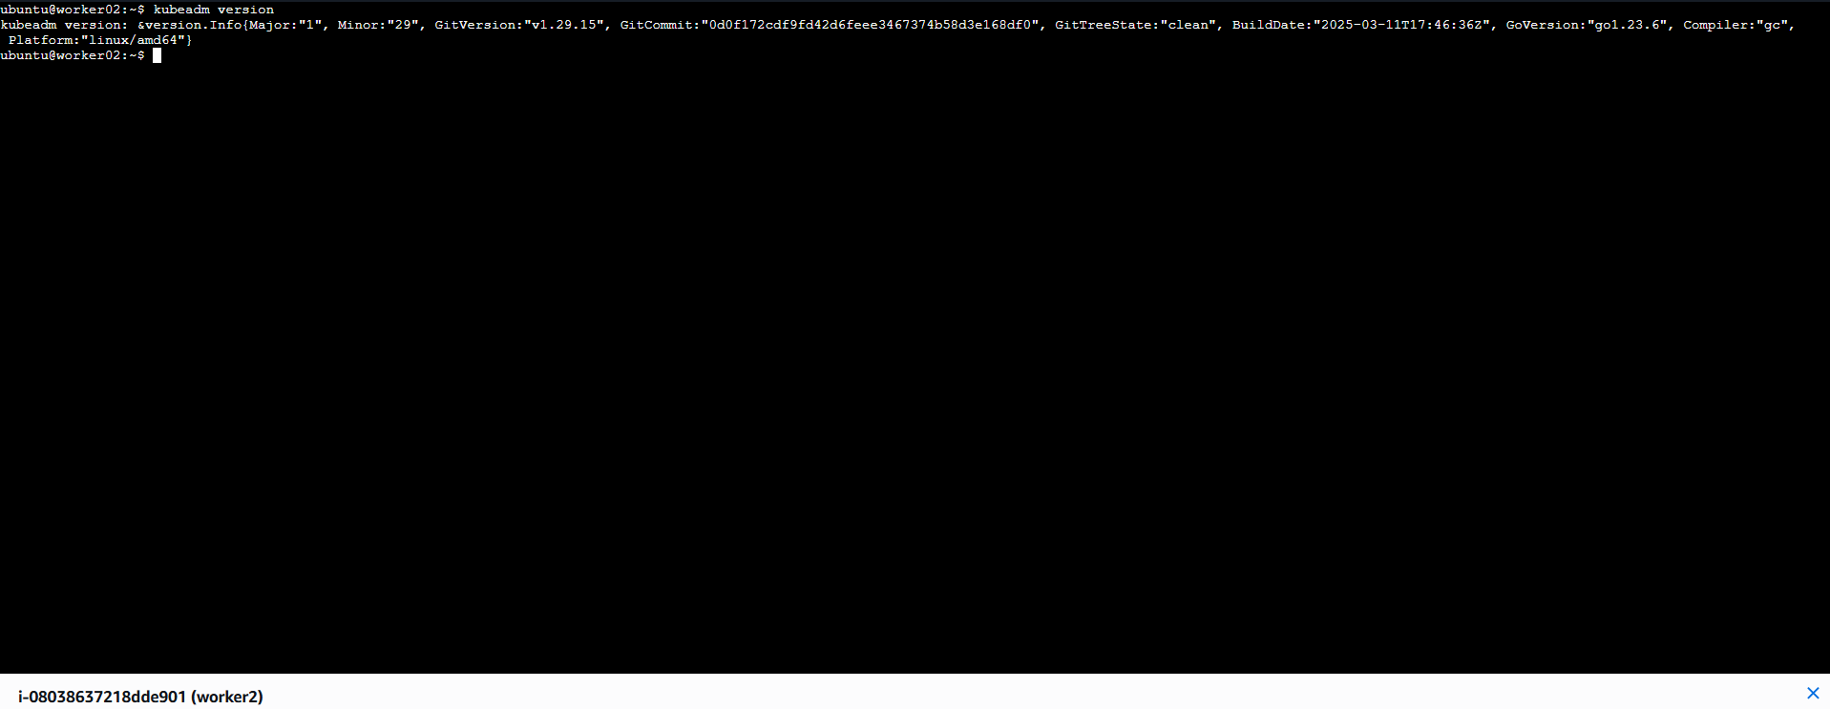
Based on the terminal output and the highlighted sections in your image, here is the step-by-step breakdown of what was just performed on your Kubernetes Master Node:
1. Installing the Container Runtime
The first command, sudo apt install -y containerd, installs containerd. This is the software responsible for managing the complete container lifecycle (pulling images, starting/stopping containers) on the host machine.
2. Creating the Configuration Directory
sudo mkdir -p /etc/containerd creates the directory where the configuration file for containerd will live. The -p flag ensures the command doesn't error out if the directory already exists.
3. Generating the Default Configuration
sudo containerd config default | sudo tee /etc/containerd/config.toml takes the "factory default" settings of containerd and saves them into a file called config.toml. This gives you a clean starting point for customization.
4. Enabling the Systemd Cgroup Driver
This is a critical step for Kubernetes stability:
sudo sed -i 's/SystemdCgroup = false/SystemdCgroup = true/' /etc/containerd/config.toml
- Why? Kubernetes uses systemd to manage processes. If containerd uses a different driver (the default is often cgroupfs), the system has two "bosses" managing resources, which causes nodes to crash. This command ensures containerd and Kubernetes are both using systemd.
5. Applying the Changes
sudo systemctl restart containerd restarts the service so that it actually starts using the new config.toml

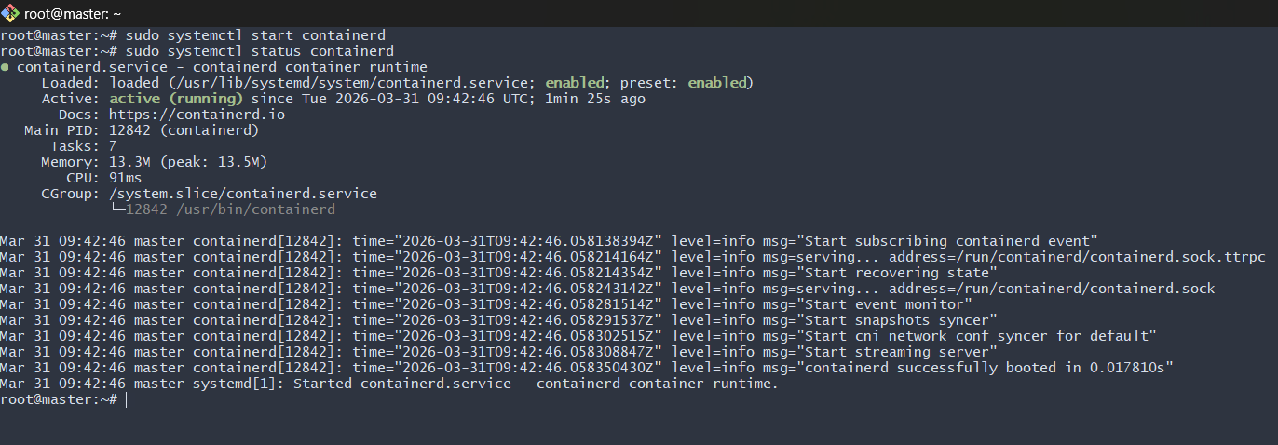
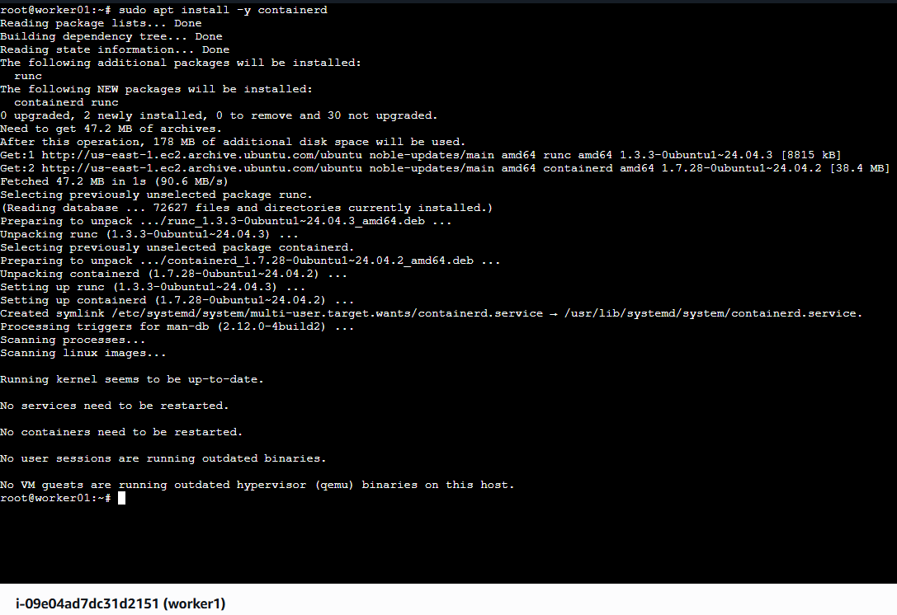
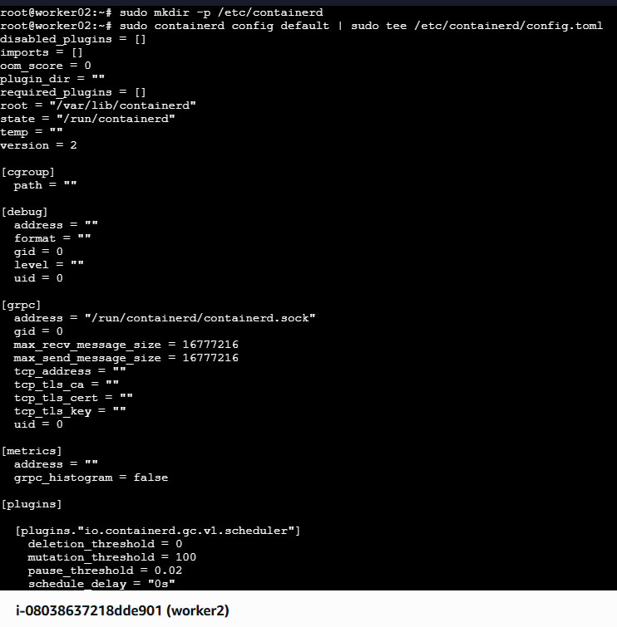
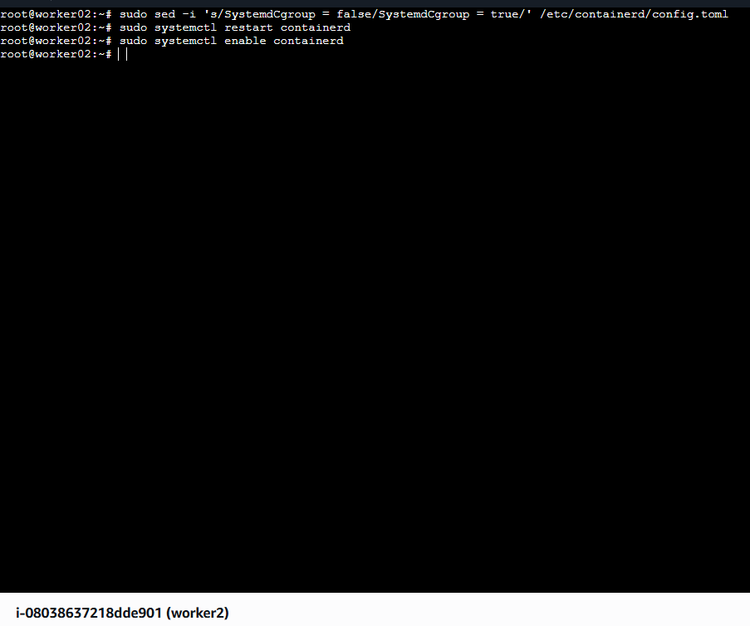
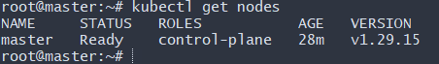
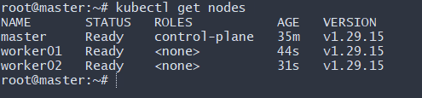
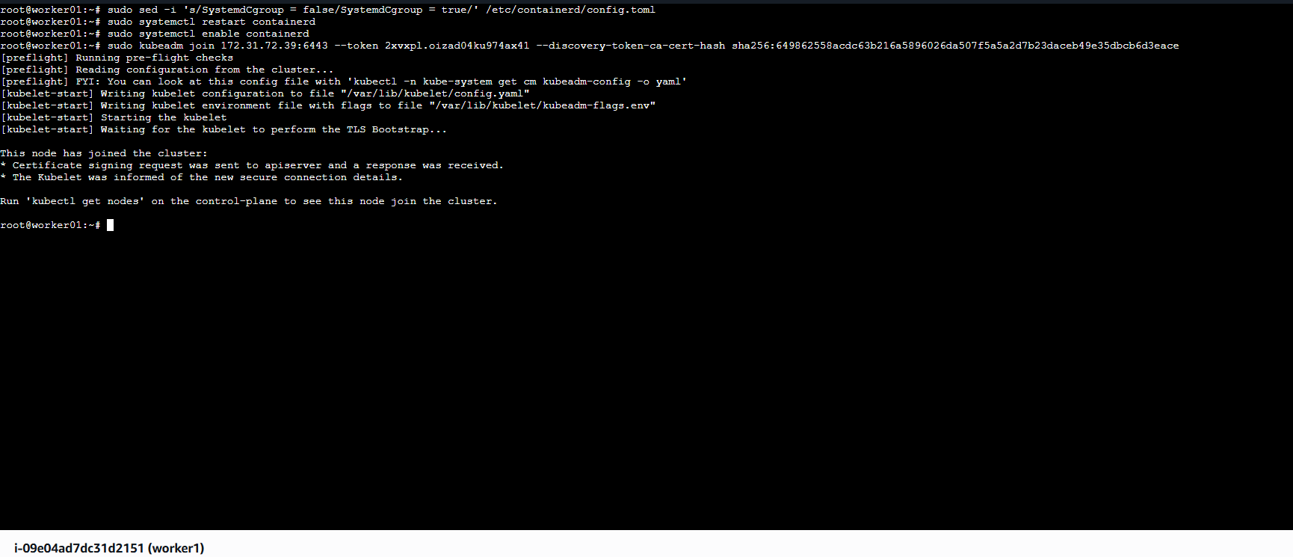
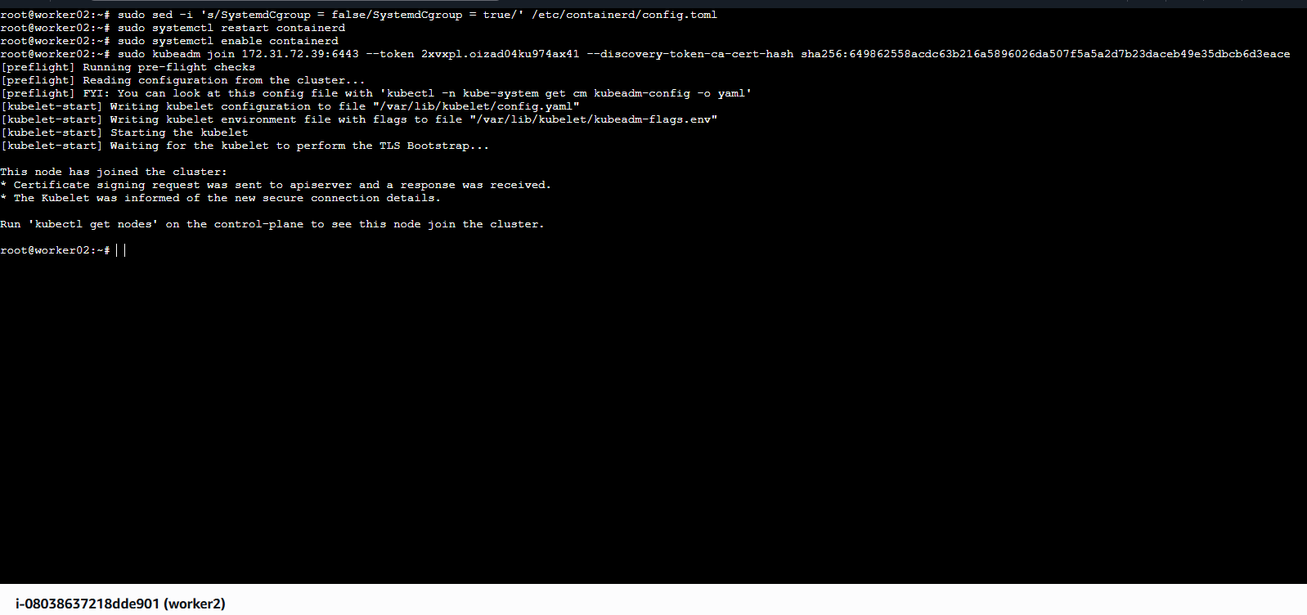
3. Run one nginx pod.

Step 1: Create Nginx Pod (From Master Node)

ran:

kubectl run nginx-pod --image=nginx --restart=Never

What This Does:

Creates a pod named nginx-pod

Uses official nginx image from Docker Hub

--restart=Never ensures it creates a Pod (not Deployment)

Step 2: Verify Pod Creation

checked the pod status:

kubectl get pods -o wide

Output showed:

STATUS → Running

Pod IP → 10.10.30.66

Node → worker02

This confirms:

Pod scheduled successfully

Network working (Calico CNI)

Worker node is functional

Step 3: Describe Pod for Detailed Information

ran:

kubectl describe pod nginx-pod
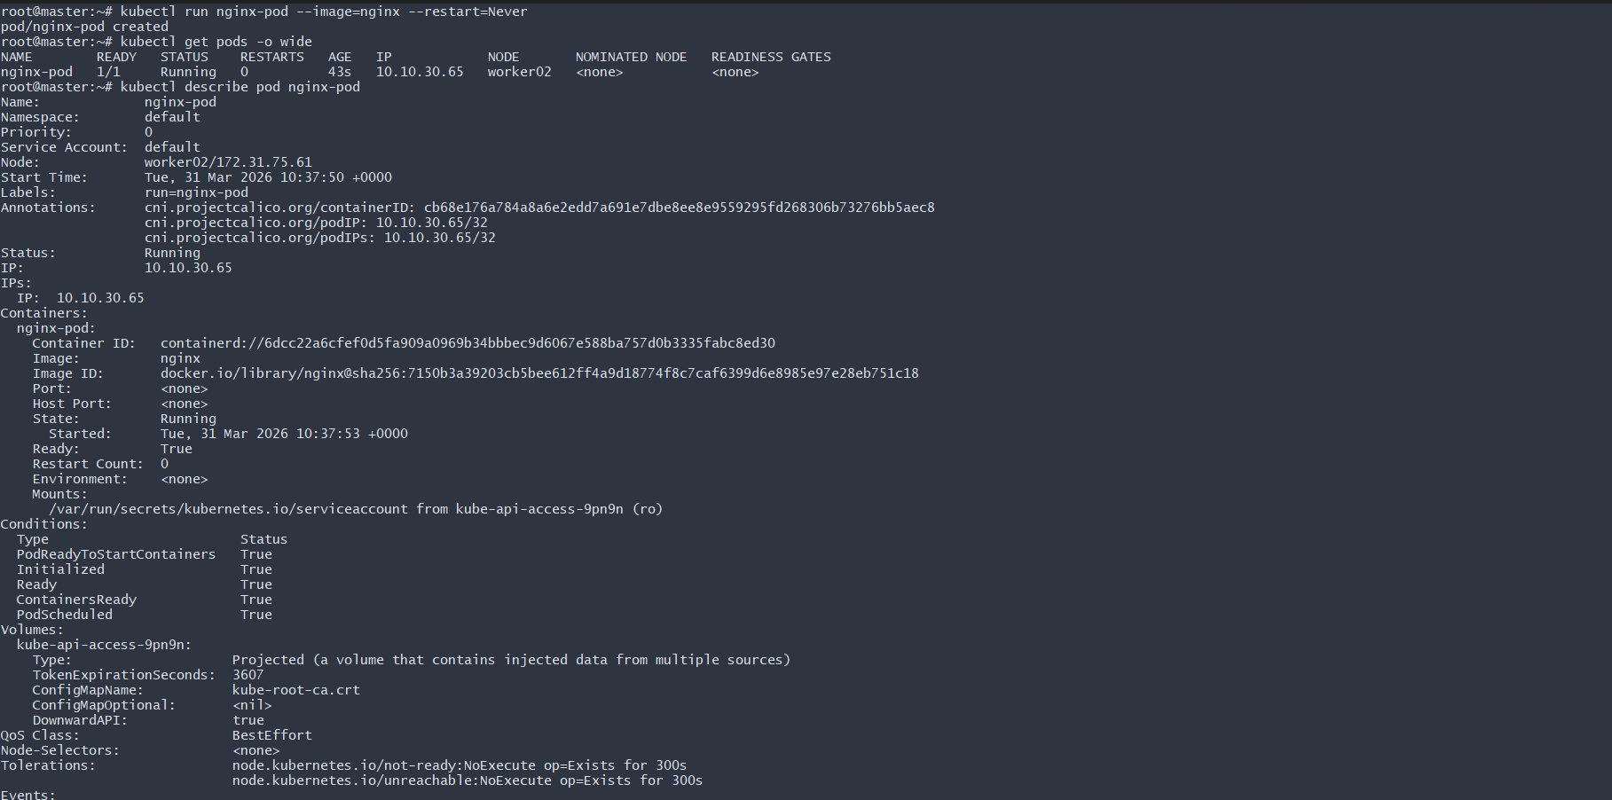
4. Mugup Master and slave components on k8s.
1. Control Plane (Master Node)
The control plane manages the entire Kubernetes cluster. It makes scheduling decisions and maintains the desired state.
Components:
1) kube-apiserver
- Entry point of the cluster
- All kubectl commands go through it
- Validates and processes API requests
- Communicates with etcd
2) etcd
- Key-value database
- Stores cluster state
- Stores:
  - Pods
  - Services
  - Secrets
  - ConfigMaps
  - Node information
3) kube-scheduler
- Assigns Pods to worker nodes
- Decides based on:
  - CPU and memory availability
  - Taints and tolerations
  - Node selectors and affinity rules
4) kube-controller-manager
Runs multiple controllers, such as:
- Node Controller
- ReplicaSet Controller
- Deployment Controller
- Job Controller
Ensures actual state matches desired state.

2. Worker Node (Slave Node)
Worker nodes run the application workloads.
Components:
1) kubelet
- Agent running on each worker node
- Receives instructions from control plane
- Ensures containers are running
- Reports node status to control plane
2) kube-proxy
- Handles networking rules
- Maintains iptables rules
- Enables communication between services and pods
3) Container Runtime
- containerd (recommended)
- Responsible for running containers
- Pulls images and starts containers

Architecture Flow
- User runs kubectl command
- Request goes to kube-apiserver
- Scheduler selects a worker node
- kubelet on that node creates the Pod
- Container runtime runs the container

In Your Current Cluster
Master node:
- Runs control plane components:
  - kube-apiserver
  - etcd
  - scheduler
  - controller-manager
Worker nodes:
- Run:
  - kubelet
  - kube-proxy
  - containerd
- Host application Pods

